The Geography of Immigrants in Same-Sex Couples in the United States

Nathan I. Hoffmann, Department of Sociology, UCLA

Kristopher Velasco, Department of Sociology, Princeton University

February 10, 2025

Abstract

Where do LGBTQ+ immigrants settle in the United States? The policy landscape for same-sex couples in the U.S. has changed rapidly in recent years, with immigrants being particularly affected. After the 2013 end of the Defense of Marriage Act, U.S. citizens could finally sponsor the visa of a same-sex partner, and number of immigrants in same-sex couples increased rapidly. But little is known about where these lesbian, gay, and bisexual (LGB) immigrants choose to settle and enjoy their new rights. Do they behave more similarly to their straight immigrant counterparts and locate based on job opportunities and cost of living? Or do they gravitate toward more LGBTQ+-friendly cities and states, as U.S.-born LGB people do? How have these patterns changed over time, especially in response to local policy changes relevant to LGBTQ+ people and immigrants? Using American Community Survey data from 2008-2022 and original datasets, this paper implements descriptive analyses and quasi-Poisson models to study how settlement patterns of immigrants in same-sex couples in the U.S. respond to local and national policy changes as well as other local sociodemographic and economic factors. We find that the distribution of immigrants in same-sex couples is expanding across the U.S. over time. These settlement patterns generally look more similar to fellow U.S.-born LGB Americans: locations with higher concentrations are more progressive, have more robust LGBTQ+ civic life, and have higher incomes. Yet immigrants in same-sex couples also live in more racially and ethnically diverse areas compared to U.S.-born Americans in same-sex couples. Our findings contribute to a fuller understanding of this rapidly growing population and under which conditions they may behave more similarly to their fellow migrants, their fellow sexual minorities, or as a distinct population all their own.xx

# Introduction

There is great interest in residential equity and the geographic distribution of people living in the United States. These spatial patterns are linked to a variety of important demographic and social outcomes like health and well-being, exposure to environmental and social hazards, access to quality education, and social capital, among others. Changing legal landscapes are salient factors influencing settlement patterns. This is especially true for LGBTQ+ migrants, whether for asylees seeking refuge from repressive contexts, elite LGBTQ+ migrants selecting ideal cosmopolitan destinations, or those wanting to be reunified with their binational partner (Carrillo 2018; Mai and King 2009; Gorman-Murray 2009; Vogler 2016; Choi 2022; Di Feliciantonio and Gadelha 2016; Hoffmann and Velasco 2024a). A notable policy development relevant to this latter group came in 2013, when the U.S. Supreme Court overturned the Defense of Marriage Act and required the U.S. government to recognize marriages between same-sex spouses. This decision radically changed the immigration landscape: For the first time, same-sex spouses of U.S. citizens and lawful permanent residents were eligible to file a spousal or fiancée petition for an immigrant visa (Edwards 2013). In the years since, the U.S. population of lesbian, gay, and bisexual (LGB) immigrants has grown rapidly. As Hoffmann and Velasco (2024a) show, numbers of different-sex couples (whether cohabiting or married) containing immigrants increased by 22 percent from 2008 to 2019 (from 7.8 million to 9.5 million), while those of corresponding same-sex couples grew by 140 percent in the same period (from 44 thousand to 107 thousand).

Despite increased interest on this growing population, especially in the wake of the DOMA decision, little is known on *where* LGB migrants settle and enjoy their new rights after in the U.S. Do they gravitate toward LGBTQ+-friendly cities and states, or are they more concerned with job opportunities and cost of living? How have these patterns changed over time, especially in response to local policy changes relevant to LGBTQ+ people and immigrants? In other words, research makes clear that LGBTQ+ migrants often feel caught between their sexual identity and migrant community. Do patterns of settlement, therefore, align with their fellow migrant or, instead, does their dispersion reflect U.S-born, LGB counterparts? Addressing this question, even descriptively, offers important insights into how social processes ultimately affect populations caught against (potentially) countervailing forces.

This paper implements descriptive and regression analyses to study how settlement patterns of immigrants in same-sex couples in the U.S. respond to local and national policy changes as well as other local factors. We leverage data from the American Community Survey, spanning 2008-2022, to do so. Results suggest that the distribution of immigrants in same-sex couples dramatically expanded during this time period. Moreover, settlement patterns generally look more similar to fellow U.S.-born LGB Americans: locations with higher concentrations are more progressive, have more robust LGBTQ+ civic life, and have higher incomes are associated with more immigrants in same-sex couples. Yet one important contrast is that immigrants in same-sex couples also live in more racially and ethnically diverse areas compared to U.S.-born Americans in same-sex couples. Suggesting that while broadly adhering more closely to U.S.-born geographic patterns, these particular migrants still seek more (relatively) diverse neighborhoods. Our findings contribute to a fuller understanding of how this rapidly growing population and under which conditions they may behave more similarly to their fellow migrants, their fellow sexual minorities, or, which is increasingly the case, act as a distinct population all their own.

# Background

We combine two often distinct literatures, one on immigrant settlement patterns and the other on LGBTQ+ residential dispersion, to understand where immigrants in same-sex relationships live in the U.S. Migration scholars are particularly interested in the distribution of migrants to understand processes like integration and assimilation into native society. But this question if whether immigrants integrate into native-born communities or remain segregated into distinct enclaves is applicable to the residential patterns of LGBTQ+ populations. Research finds LGBTQ+ communities, particularly gay men, to historically concentrate in urban neighborhoods, i.e., “gayborhoods,” but, now, this concentration is declining – perhaps indicating greater social acceptance as LGBTQ+ individuals integrate into other geographic areas (A. Spring and Ghaziani 2024). As immigrants in same-sex couples continue to rapidly expand (Hoffmann and Velasco 2023), this case allows us to understand where these individuals locate amid differing pressures and whether they adhere most similarly to their co-migrants or, instead, live in areas better aligned with their U.S.-born LGB counterparts. Of course, a third option exists, which is that immigrants in same-sex couples, along with LGBTQ+ migrants more broadly, represent a distinct population whose residential patterns are unlike either of their two adjoining counterparts. Knowing where LGBTQ+ migrants locate, though, can better determine where services and social support need to be targeted and which social forces are most salient to a rapidly expanding population exposed to several countervailing trends.

## Immigrant Settlement in the United States

There is a long history in migration studies investigating settlement patterns. Theories of destination choice upon entering a country are similar to theories of migration more broadly. At one level, neoclassical economic theories predict that migrants will follow wage and unemployment differentials to places with high labor demand (Hatton and Williamson 2005; Todaro 1980). Newbold (1999) shows how these economic factors help explain settlement patterns in the U.S., also pointing to the importance of government welfare programs and the local immigration rate. This last effects highlights the importance of migrant networks that share information and resources to lower the cost of migration and settling in the destination – suggesting that migrants settle in other migrant-heavy locations because of network effects (Massey et al. 1987). Similarly, institutions that arise to recruit workers and ease entry and settlement can promote migration to particular destinations (Hernández-León 2013). Local political factors can also influence migrant settlement. For example, Watson (2013) shows that U.S. metropolitan areas that adopt 287(g) agreements – allowing local agencies to enforce Federal immigration law – see significantly greater propensity of immigrants to leave and relocate within the United States. Indeed, as migration policies become more strict in the U.S., we generally see this having xxeffectxx.

Settlement also varies by individual-level characteristics. South, Crowder, and Chavez (2005) find greater spatial assimilation for Latino immigrants – i.e., they are more likely to live among non-Hispanic, White Americans – when they have greater human and economic capital and greater English proficiency. Iceland and Scopilliti (2008) find similar results, with migrants more likely to live among the U.S.-born when they have been in the U.S. longer, have higher earnings, and own a home.

Scholars have turned to studying so-called “new” immigrant destinations in the U.S. in recent years. Mass migration of the late 1800s and early 1900s was characterized by immigrants from Europe who tended to settle in densely populated urban areas, especially major Eastern and Midwestern cities such as New York and Chicago. As the century progressed, migration from Europe was mostly cut off (Waldinger, Hoffmann, and Catron 2023; Zolberg 2008). As migration from Latin America increased, major cities along the Southern border – especially in California and Texas – saw the greatest growth in migrants (Chiswick and Miller 2004). But in a trend first noticed in the 1990s and early 2000s (Durand, Massey, and Charvet 2000; Singer 2004; Zúñiga and Hernández-León 2005; Massey 2008), migration to urban areas slowed and migrants relocated to rural areas and small towns in the Sun Belt and the Deep South. Flippen and Farrell-Bryan (2021) offer three explanations for this shift. First is an economic explanation: An overabundance of workers in traditional gateways – driven in part by mass legalization in the 1990s – resulted in excess labor supply, especially in California. At the same time, manufacturing and meat processing plants relocated to lower-wage, right-to-work states that were experiencing population growth and a demand for construction (Ribas 2015). Second, labor recruitment contributed to the movement of migrants from traditional areas to the new destinations, and migrant networks sustained the new migrant pathways (Stuesse 2016). Finally, increased immigration enforcement and hostile policies in the 1990s in border states such as California drove migrants further east (Durand and Massey 2019). Due to their lack of established migrant communities, dynamics of settlement differ in these new destinations: Comparing new and established migrant destinations, Hall (2013) finds greater segregation in new destinations, even when controlling for other local factors and individual characteristics. That said, if immigrants in same-sex couples are represented within these mass migration dynamics, generally, then we’d expect their spatial patterns to fall along these lines.

## Distribution of Same-Sex Couples in the United States

Concerns of residential distribution, segregation, and equity have also been a prominent line of research for LGB populations in the U.S., generally, and same-sex couples, specifically. Similar to settlement patterns of migrants, LGB Americans are also influenced by the role of economic conditions. For example, those in same-sex couples are generally found to be in areas with greater socioeconomic conditions, such as with more college-educated individuals, higher property values, and access to better local amenities (Florida 2003; Black et al. 2002; Lee et al. 2018). These patterns reflect same-sex couples’ relatively higher discretionary income and ability to take advantage of local amenities and spend more on housing (Black et al. 2002). Of course, the relative privilege of same-sex couples stands in opposition to LGBTQ+ communities, as whole. But just like heterosexual counterparts, cohabiting and married couples are disproportionately of better socioeconomic statusxx. Consistent findings also highlight the role of network effects, with same-sex couples located in areas with high concentrations of other same-sex couples – similar to other ethnic and migrant enclaves. Even beyond the U.S., concentration in urban settings among other LGB couples is typical and this effect is even stronger for single individuals compared to those in couples (**carpio-pinedo_2025_castro?**; **wimark_2014_the?**). This clustering may be happening, not only in addition to network effects, but because higher concentrations help to protect same-sex couples from violence and harassment (Hayslett and Kane 2011; Lee et al. 2018). Because of this common concentration pattern, though, the vast majority of research investigating residential patterns of same-sex couples focuses on urban gayborhoods (Ghaziani 2016). And, this urban-focused scholarship commonly extends to the transformation of gayborhoods, as well, and the on-going changes in sexuality-based residential segregation (Ghaziani 2016; A. Spring and Ghaziani 2024). Finally, one distinct characteristic is the role of progressive policies such as same-sex marriage and non-discrimination protections in influencing attitudes toward migration and actual migration practices (Baumle, Miller, and Gregory 2023). Marcén and Morales (2022) finds that the legalization of same-sex marriage across U.S. states led to an increase in same-sex couples moving to those states, but only for men in such couples.

Taken together, these trends have often emphasized same-sex couples living in urban gayborhoods with access to (relatively) more progressive legal environments. But both changes in demographic trends and academic attention have shifted greater attention to LGB individuals and same-sex couples living beyond these particular locales. From 2000 to 2010, and continuing to 2020, the concentration of same-sex couples in segregated, urban communities has declined (A. L. Spring 2013; A. Spring and Ghaziani 2024). Current research finds that these neighborhoods have become gentrified and rising costs have led same-sex couples, which are disproportionately comprised of gay men, to move to other parts of a city or out of particular urban centers altogether (**gentrification?**). Others meanwhile, find that discriminatory lending practices also encourage dispersion of same-sex couples to other locations (A. Spring and Ghaziani 2024). These trends underscore the argument made by Stone (2018) that researchers of LGBTQ+ geography need to look beyond the “great cities” and toward more ordinary cities, the South, and rural locales to get a more holistic understanding of LGBTQ+ geographic patterning in the U.S. Indeed, same-sex couples are increasingly represented in red states and rural counties, which can either reflect displacement out of cities and/or increasing acceptance and integration of these unions across the country (Marino et al. 2024).

Unfortunately, much of the information on LGBTQ+ residential location in the U.S. is based on couple information and at aggregate levels. Reliance on data from the decennial census and the American Community Survey have necessarily constrained insights to those in cohabiting, same-sex couples (whether married or unmarried). Representative, quantitative data is quite limited at the individual level. There has also been a bias to examine urban residential patterns despite clear movement toward suburban and rural locations (Marino et al. 2024). More research is needed, then, to understand patterns at lower levels of aggregation – both geographically and at observation unit (A. Spring and Ghaziani 2024).

## Residential Expectations for Immigrants in Same-Sex Couples in the United States

To date, most quantitative research on same-sex couples implicitly assumes all respondents are U.S.-born since nativity status is neither explicitly asked nor ever specified. Consequently, it is unknown whether the patterns exhibited above reflect immigrants in similar unions. However, existing qualitative work can nevertheless set up some empirical expectations. Studies demonstrate that LGBTQ+ migrants coming to Western countries, like the U.S., see cities as desirable destinations, especially as cities have come to promote themslves as inclusive toward LGBTQ+ communities (**binnie?**). However, migrants from non-Western settings or from lower socioeconomic conditions are often excluded from domestic LGBTQ+ spaces and find their integration into existing LGBTQ+ residential and social infrastructure challenging. Indeed, (**guomundsdottir_2024_north?**) finds privileged migrants, particularly white migrants, capable of integrationg into existing LGBTQ+ spaces and patterns of social life in Iceland, but not necessarily LGBTQ+ migrants outside of these categories. Considering that recent waves of migration into the U.S. consist of people Latin America and Asia, these may be the precise populations that experience exclusion. Consequently, their residential patterns may not necessarily look like their U.S. LGB counterparts but, instead, find greater inclusion in their areas dominated by their co-migrants.

Existing qualitative research on the residential processes of LGBTQ+ migrants often highlight their exclusion from mainstream LGBTQ+ spaces because these studies disproportionately focus on asylees and individuals seeking refuge in the U.S. Consequently, these samples are highly-selected to experience social exclusion. Moreover, this profile of LGBTQ+ migrant stands in contrast to the characteristics of immigrants in same-sex relationships at the population-level. Hoffmann and Velasco (2023) find that immigrants in same-sex couples, whether married or cohabiting, are quite privileged. Compared to immigrants in different-sex couples, those in same-sex couples come from richer, more democratic, and more LGB-friendly countries. Immigrants in same-sex couples also tend to be more highly educated, work in more prestigious occupations, and have higher incomes. These are the immigrants, then, that are perhaps best positioned to integrate into existing LGBTQ+ spaces and, in effect, have residential patterns that are more akin to their U.S. counterparts. One important reason for this disproportionate privileged positioning and reason for reflecting their U.S.-born counterparts as opposed to fellow migrants is because a significant number of these immigrants are in binational arrangements with a U.S.-born counterpart (Hoffmann and Velasco 2024a). After the end of the Defense of Marriage Act in 2013, U.S citizens could sponsor a spousal and fiance visa for their same-sex partner for the first time – dramatically increasing the number of immigrants in same-sex couples in the U.S. (Hoffmann and Velasco 2024a). And, emergent research shows how these immigrants get integrated into the normative cultures of U.S. life as opposed to their U.S.-born partner being pulled toward immigrant communities reflective of their new same-sex partner (**seo_2024_quotidian?**).

Of course, there is also the real possibility that immigrants and same-sex couples, and LGBTQ+ migrants more broadly, represent their own distinct population and have residential patterns that do not reflet either their co-national or U.S. counterparts. Hoffmann and Velasco (2024b) show that U.S. citizens tend to see LGB migrants as less deserving of admission and less culturally similar to the U.S. than other migrants. Due to their greater personal privilege as well as this LGB-migrant-specific antagonism from larger society, LGB migrants may concentrate in their own unique enclaves.

# Data and Methods

Our main source of data is the American Community Survey (ACS) for 2008 to 2022 (except for 2020, when data quality was not of adequate quality) (Ruggles et al. 2024). Each year, the ACS surveys a 1-percent representative sample of U.S. households about their education, occupation, income, family structure, immigration status, country of origin, location, and a variety of other individual and household attributes. We define a same-sex couple as two individuals of the same sex in the same household who report their relationship as “spouse” or “unmarried partner.” We limit the sample to individuals age 18 to 64, and immigrants in the sample migrated at the age of 18 or older.

We consider the spatial distribution of three groups: immigrants in same-sex couples (unweighted $N$ = 13,284), immigrants in different-sex couples ( $N$ = 1,575,975), and individuals in same-sex couples where neither individual is an immigrant ( $N$ = 173,546). The weighted sample is equivalent to 193 million individuals over the 14 years of data.

We use “LGB” to refer to all individuals who may be in romantic relationships with members of the same sex, although we recognize that some individuals in same-sex relationships may not identify as lesbian, gay, or bisexual. We also recognize that we are not able to identify bisexual (or pansexual, multisexual, etc.) individuals cohabiting with different-sex partners. Furthermore, measuring the prevalence of same-sex couples in the U.S. is difficult (Michaels 2013). As in most nationally representative demographic work on same-sex couples (Baumle 2013; Baumle and Dreon 2019), we are able to identify only LGB couples that cohabit; unpartnered LGB individuals and those who do not live with their partner are not included in the analysis (Baumle, Compton, and Poston 2009, 6). In addition, LGB individuals who do not feel comfortable with the partner labels of the ACS are not in the sample. Another pitfall is measurement error: Misreporting may result when different-sex couples accidentally misspecify the gender of one of the partners (Gates and Steinberger 2009; Goodnature and Neto 2021). Beginning in 2008, the Census Bureau made changes to ACS gender and partnership questions in order to prevent such errors (U.S. Census Bureau 2013), so we rely on data only from 2008 onward, but difficulties remain. If even a small number of different-sex couples misreport one partner’s sex, the counts of same-sex couples will be inflated. Following Gates and Steinberger (2009), we remove all respondents that had either their relationship or sex variable allocated by the Census Bureau. This is the strategy used by most studies of same-sex couples in the ACS (e.g. Boertien and Vignoli 2019; Gates 2013; Goldberg and Conron 2021; Christafore and Leguizamon 2019; Martell and Nash 2020).

Most of our variables come from the ACS and are calculated at the level of the Public Use Microdata Area (PUMA), a geographic unit of analysis that covers a population of at least 100,000 and does not cross state lines. PUMAs partition the entirety of the United States, and most of our analyses are at the level of the country as a whole.

We consider a variety of variables at the PUMA level in the ACS. First are variables relevant to economic considerations; neoclassical economic theory suggests that immigrants choose to settle in areas with greater economic opportunities. We expect that people want to live in places with better job opportunities, as long as the cost of living is not too high. We include the percentage of individuals in the PUMA who hold at least a bachelor’s degree, who own their own home, whose income is under 100% or 200% of the poverty line, and who are unemployed. We also consider the mean PUMA-level values of personal income, Hauser-Warren occupational prestige score (HWSEI, Hauser and Warren 1997), value of home (in $1000s), rent, and cost of electricity.

Second, we consider variables relevant to social considerations. Based on theories of immigrant networks and the migration industry, we expect the immigrants will want to live near other immigrants and with organizations that ease migration. Individuals may also take other social aspects into consideration, such as racial composition and density. From the ACS, we calculate the percentage of individuals in the PUMA who are immigrants (born outside the U.S.), who identify as Black, who identify as Hispanic. We also use a measure from the ACS of the density of the PUMA in persons per square mile.

We also use social data from two other sources. First, to examine LGB policies at state of destination, we use original datasets. We predict that LGB migrants will prefer to live in states with more progressive LGB policy. To create the U.S. state policy index, we compile data from the Movement Advancement Project[1], a leading LGB organization in the U.S. that collects data on a number of relevant policies. A higher score represents more progress state-level policies. Progressive policies include full marriage equality, state recognition of civil unions and domestic partnerships, ban on all employment and housing discrimination based on sexual orientation, hate crime protections based on sexual orientation, legal joint adoption by same-sex couples, and a ban on conversation therapy for minors. For regressive policies, we consider criminalization of sodomy, state constitutional bans of marriage equality, religious freedom exemptions to discriminate against same-sex couples in adoption, and state-level bans on local non-discrimination ordinances encompassing sexual orientation. Due to data unavailability at the time of writing, we use 2019 values for 2021 and 2022. The state index ranges from -2 to 7, and the mean state policy score in this time period is 3.4.

Our second outside data source is a measure of the prevalence of LGBTQ+ and immigrant-serving nonprofits in a given PUMA. We expect that LGB migrants will choose to live in areas with more LGBTQ+-serving nonprofits, and we expect that migrants more broadly will prefer to live in areas with more immigrant-serving nonprofits. These data come from the Internal Revenue Service’s Business Master File (BMF). The BMF collects basic, administrative data on all tax-exempt entities required to submit a Form 990 annually. For our purposes, we restrict our sample to just 501c(3) charitable organizations. Additionally, the IRS assigns each organization an activity code from the National Taxonomy of Exempt Entities (NTEE). These NTEE codes help designate whether an organization is focused on “Arts & Culture” (code: A20) or “Homeless Shelters” (code: L82). We classify nonprofits with NTEE codes “Ethnic & Immigrant Centers (code: P84) and”Immigrant Rights” (code: R21) as immigrant serving. While LGBTQ+ nonprofits are those designed as “LGBT Centers” (code: P88) and “Lesbian & Gay Rights” (code: R26). We additionally supplement our classification of LGBTQ+ nonprofits with those used by Velasco and Paxton (2022), who found LGBTQ+ nonprofits operating under other classification designations. To calculate a PUMA-level measure of these nonprofits, we use their ZIP code to approximate the number of nonprofits in a PUMA in a given year. Due to data unavailability at the time of writing, we use 2021 data for 2022.

Our analyses are descriptive, presenting and comparing the contours of the populations of immigrants in same-sex couples, immigrants in different-sex couples, and U.S.-born in same-se couples. Means for individual variables by group are presented in Table 1, and PUMA-level geographic variables by group are presented in Table 2. We also examine the state-level proportion of immigrants in same-sex couples as well as the the variation in both individual and geographic variables over time.

# Results

## Individual Characteristics

Table 1 presents means of individual variables for immigrants in different-sex couples, immigrants in same-sex couples, and U.S.-born individuals in same-sex couples, while Figure 2 shows how the group means of a numeric subset of these variables change over time. Beginning with socioeconomic characteristics, individuals in same-sex couples – regardless of nativity – are generally more advantaged than immigrants in different-sex couples. This is true for annual income, occupational prestige score (as measured by the Hauser and Warren Socioeconomic Index), high school completion, or college completion. Income and occupational prestige are nearly indistinguishable between the two groups of LGB individuals. Interestingly, compared to U.S.-born LGB individuals, LGB immigrants have lower rates of high school completion but higher rates of college completion. This implies a bimodal distribution: LGB immigrants consist of individuals with high education and those with relatively little education.

LGB individuals in general are much less likely than heterosexual ones to have children, however, before 2015, LGB immigrants were more likely to have children than the LGB U.S.-born. In recent years both LGB groups are equally likely, to have children, at about 20 percent. Children of LGB people tend to be from previous heterosexual relationships, which may have been more likely for LGB immigrants in the past. LGB migrants have also become younger than heterosexual ones in recent years.

Turning to identity characteristics, immigrants in same-sex couples are more likely to be White than those in different sex couples (28 compared to 19 percent), but much less likely to be white than the U.S.-born in same-sex couples (77 percent). Proportions of Black and Hispanic LGB immigrants are similar to those for heterosexual immigrants, but the proportion Asian is lower (23 percent for LGB compared to 31 percent for heterosexuals). As for sex, while there are slightly more females than males among heterosexual immigrants and the LGB U.S.-born, there are nearly twice as many males than females among LGB migrants.[2]

## Geographic Characteristics

To show broadly how the geography of immigrants in same-sex couples has changed over the past 15 years, Figure 1 presents the percentage coupled immigrants in each state who are in same-sex couples and how these figures have changed over time. The figure shows maps for three time periods: 2008-2012, 2013-2017, and 2018-2022. Most states had greater proportions of immigrants in same-sex couples in 2022 than in 2008. In addition, the pattern of growth is meaningful. Shortly after the end of the Defense of Marriage Act in 2013 – when U.S. citizens and permanent residents could finally sponsor the visa of a same-sex partner – their growth was concentrated in the Northeast, where states were relatively early adopters of same-sex marriage, including Massachusetts (2004), Connecticut (2008), Vermont (2009), New Hampshire (2010), New York (2011), Maine (2012), and Maryland (2013). However, in the next period (2018-2022), more of the map shows higher percentages of immigrants in same-sex couples, including more relatively conservative states.

In the Appendix Figure 4, we present maps of subgroup distributions. Aggregating all of our years of data, these maps show the percentage of immigrants in same-sex couples in a given state who belong to three types of subgroups: ethnicity, sex, and whether they have children. Higher proportions of LGB immigrants with children live in the Midwest than the coasts.

Table 2 presents descriptive statistics for PUMA-level characteristics, separated by the three groups of interest: immigrants in different-sex couples, immigrants in same-sex couples, and non-immigrants partnered with same-sex non-immigrants. In the table, all variables are averaged over the full range of survey years. Immigrants in same-sex couples tend to be more similar to immigrants in different-sex couples than non-immigrants in same-sex couples. Most notably, immigrants in same- and different-sex couples live in areas with similar proportions of immigrants and Hispanic people, with higher home values and rent, and in denser areas. However, immigrants in same-sex couples live in areas with somewhat more advantage than the other two groups. They live in areas with higher incomes and higher occupational prestige, and the home and rent prices of their areas are somewhat higher than those of immigrants more broadly. They also live in denser areas.

Clear differences also arise around two variables relevant to LGBTQ+ people. First, although all three groups tend to live in relatively progressive states with a score of at least 3, immigrants in same-sex couples live in states with an average score of nearly 4. Also notable are differences around the number of LGBT nonprofits. On average, immigrants in same-sex couples live in PUMAs with 1.2 LGBT nonprofits, while LGB non-immigrants live in PUMAs with 0.76 and immigrants in different-sex couples with 0.30. They also live in areas with more immigrant nonprofits, with an average of 1.0. Surprisingly, the number of immigrant nonprofits for the average immigrant in a different-sex couple and average non-immigrant in a same sex couple are quite similar, at about 0.8.

Figures ?? and ?? show how these differences are fairly stable over time. One notable change is the average percent of Black residents in the typical area for each group: Around 2010, immigrants in same-sex couples were 1 to 2 percentage points more likely to live in areas with Black respondents than the other groups, but in recent years the numbers are very similar.

# Discussion and Conclusion

In 2013, the U.S. Supreme Court overturned the Defense of Marriage Act and required the U.S. government to begin recognizing marriages between same-sex spouses. Once immigrants in same-sex couples had access to spousal and finané(e) visas, their numbers increased rapidly (Hoffmann and Velasco 2024a). Where is it, then, that these immigrants settle in the United States over time? Investigating this question is important given the strong connection between residential distribution and a variety of important demographic and social outcomes such as health and well-being, exposure to environmental and social hazards, access to quality of education, and social integration.

First, we find that immigrants in same-sex couples are increasing their geographic distribution across the United States from 2008 to 2022. This trend underscores findings by Marino et al. (2024) and A. Spring and Ghaziani (2024) showing county-level and metropolitan-level distributions in same-sex couples overall.

Second, when descriptively comparing the types of areas immigrants in same-sex couples live compared to immigrants in different-sex couples and U.S.-born individuals in same-sex couples, we find immigrants are typically closer to trends matching their fellow immigrants. A notable exception is that immigrants in same-sex couples live in areas with greater concentration of those with Bachelor’s degrees, more LGBTQ+ nonprofits, more density, and have higher average incomes. In other words, these descriptive trends show this population to have a disproportionate draw to areas that may be more characteristic of gayborhoods (Ghaziani 2016). Yet, our OLS and quasi-Poisson models show that when compared to U.S.-born Americans in same-sex couples, their immigrant counterparts live in areas that are more Hispanic, Black, have more immigrants, and in states with even more progressive LGBTQ+ policies.

Third, rather than being more akin to one adjacent population or the other, it appears that immigrants in same-sex couples operate on their own distinct settlement patterns. These immigrants live in more diverse, cosmopolitan, and LGBTQ+ supportive locations in the United States, unlike U.S.-born same-sex couples that are increasingly spreading to conservative states and non-urban locations. Furthermore, they do not seem to be following immigrants in different-sex couples’ pathways to “new immigrant destinations.” As found by Hoffmann and Velasco (2023), this may because, as a population, immigrants in same-sex couples are some of the move privileged among immigrants – typically having higher incomes, occupational prestige, and educational attainment. Consequently, they may be in a better position to consider lifestyle migration factors than others (Carrillo 2018; Dixon 2020). However, much more research is needed to understand the direct mechanisms driving these distributional trends. Our interpretation here is only suggestive for future research.

This study is subject to a number of limitations that future research should attempt to overcome. First, ACS data limit analysis to LGB migrants in couples who live together, excluding single or non-cohabiting LGB migrants. Second, PUMAs are large (including at least 100,000 people), so analysis can not be as fine-grained as would be ideal. Especially in rural areas, PUMAs can be quite vast; research at lower levels of aggregation is necessary to better understand the settlement of these areas. Third, summary statistics from the ACS are only proxies for the lived spatial experiences of LGB migrants in these areas. In-depth qualitative work is necessary to understand how LGB migrants consider various aspects of place and space in deciding where to settle.

# References

Baumle, Amanda K., ed. 2013. *International Handbook on the Demography of Sexuality*. Vol. 5. International Handbooks of Population. Dordrecht: Springer Netherlands. <https://doi.org/10.1007/978-94-007-5512-3>.

Baumle, Amanda K., D’Lane Compton, and Dudley L. Poston. 2009. *Same-Sex Partners: The Social Demography of Sexual Orientation*. SUNY Press.

Baumle, Amanda K., and Ben Dreon. 2019. “The Demography of Sexuality.” In *Handbook of Population*, edited by Dudley L. Poston Jr., 279–88. Handbooks of Sociology and Social Research. Cham: Springer International Publishing. <https://doi.org/10.1007/978-3-030-10910-3_11>.

Baumle, Amanda K., Audrey Miller, and Elizabeth Gregory. 2023. “Effects of State-Level Abortion and LGBT Laws and Policies on Interstate Migration Attitudes.” *Population Research and Policy Review* 42 (6): 90. <https://doi.org/10.1007/s11113-023-09842-7>.

Black, Dan, Gary Gates, Seth Sanders, and Lowell Taylor. 2002. “Why Do Gay Men Live in San Francisco?” *Journal of Urban Economics* 51 (1): 54–76. <https://doi.org/10.1006/juec.2001.2237>.

Boertien, Diederik, and Daniele Vignoli. 2019. “Legalizing Same-Sex Marriage Matters for the Subjective Well-Being of Individuals in Same-Sex Unions.” *Demography* 56 (6): 2109–21.

Carrillo, Héctor. 2018. *Pathways of Desire: The Sexual Migration of Mexican Gay Men*. University of Chicago Press.

Chiswick, Barry R., and Paul W. Miller. 2004. “Where Immigrants Settle in the United States.” *Journal of Comparative Policy Analysis: Research and Practice* 6 (2): 185–97. <https://doi.org/10.1080/1387698042000273479>.

Choi, Susanne YP. 2022. “Global Multiple Migration: Class-Based Mobility Capital of Elite Chinese Gay Men.” *Sociology*, March, 00380385211073237. <https://doi.org/10.1177/00380385211073237>.

Christafore, David, and Susane Leguizamon. 2019. “Taste-Based Discrimination, Tolerance and the Wage Gap: When Does Economic Freedom Help Gay Men?” *Kyklos : Jahrbuch Des Instituts für Geschichte Der Medizin an Der Universität Leipzig* 72 (3): 426–45. <https://doi.org/10.1111/kykl.12206>.

Di Feliciantonio, Cesare, and Kaciano B. Gadelha. 2016. “Situating Queer Migration Within (National) Welfare Regimes.” *Geoforum* 68 (January): 1–9. <https://doi.org/10.1016/j.geoforum.2015.11.007>.

Dixon, Laura. 2020. “Gender, Sexuality and Lifestyle Migration: Exploring the Impact of Cosmopolitan Place-Marketing Discourses on the Post-Migratory Experiences of British Women in Spain.” *Current Sociology* 68 (3): 281–98. <https://doi.org/10.1177/0011392119850231>.

Durand, Jorge, and Douglas S. Massey. 2019. “Evolution of the Mexico-U.S. Migration System: Insights from the Mexican Migration Project.” *The ANNALS of the American Academy of Political and Social Science* 684 (1): 21–42. <https://doi.org/10.1177/0002716219857667>.

Durand, Jorge, Douglas S. Massey, and Fernando Charvet. 2000. “The Changing Geography of Mexican Immigration to the United States: 1910-1996.” *Social Science Quarterly* 81 (1): 1–15. <https://www.jstor.org/stable/42864364>.

Edwards, Benjamin P. 2013. “Welcoming a Post-DOMA World: Same-Sex Spousal Petitions and Other Post-Windsor Immigration Implications.” *Family Law Quarterly* 47 (2): 173–89.

Flippen, Chenoa A., and Dylan Farrell-Bryan. 2021. “New Destinations and the Changing Geography of Immigrant Incorporation.” *Annual Review of Sociology* 47 (1): null. <https://doi.org/10.1146/annurev-soc-090320-100926>.

Florida, Richard. 2003. “Cities and the Creative Class.” *City & Community* 2 (1): 3–19. <https://doi.org/10.1111/1540-6040.00034>.

Gates, Gary J. 2013. “LGBT Adult Immigrants in the United States.” UCLA: The Williams Institute.

Gates, Gary J., and Michael D. Steinberger. 2009. “Same-Sex Unmarried Partner Couples in the American Community Survey: The Role of Misreporting, Miscoding and Misallocation.” In *Annual Meetings of the Population Association of America, Detroit, MI*.

Ghaziani, Amin. 2016. *There Goes the Gayborhood?:* Princeton University Press. <https://doi.org/10.1515/9781400850174>.

Goldberg, Shoshana K., and Kerith J. Conron. 2021. “LGBT Adult Immigrants in the United States.” UCLA: The Williams Institute.

Goodnature, Mia, and Amir B. Ferreira Neto. 2021. “Same-Sex Unmarried Partners in the Census.” *Journal of Regional Analysis & Policy* 51 (1): 43–66.

Gorman-Murray, Andrew. 2009. “Intimate Mobilities: Emotional Embodiment and Queer Migration.” *Social & Cultural Geography* 10 (4): 441–60. <https://doi.org/10.1080/14649360902853262>.

Hall, Matthew. 2013. “Residential Integration on the New Frontier: Immigrant Segregation in Established and New Destinations.” *Demography* 50 (5): 1873–96. <https://doi.org/10.1007/s13524-012-0177-x>.

Hatton, Timothy J., and Jeffrey G. Williamson. 2005. *Global Migration and the World Economy: Two Centuries of Policy and Performance*. The MIT Press. <https://doi.org/10.7551/mitpress/3303.001.0001>.

Hauser, Robert M., and John Robert Warren. 1997. “Socioeconomic Indexes for Occupations: A Review, Update, and Critique.” *Sociological Methodology* 27: 177–298. <https://www.jstor.org/stable/271107>.

Hayslett, Karen L., and Melinda D. Kane. 2011. “‘Out’ in Columbus: A Geospatial Analysis of the Neighborhood–Level Distribution of Gay and Lesbian Households.” *City & Community* 10 (2): 131–56. <https://doi.org/10.1111/j.1540-6040.2010.01353.x>.

Hernández-León, Rubén. 2013. “Conceptualizing the Migration Industry.” In *The Migration Industry and the Commercialization of International Migration*, edited by Thomas Gammeltoft-Hansen and Ninna Nyberg Sorensen, 42–62. Routledge.

Hoffmann, Nathan I., and Kristopher Velasco. 2023. “Sexuality, Migration, and LGB Policy: A Portrait of Immigrants in Same-Sex Couples in the United States.” *International Migration Review*, August, 01979183231187623. <https://doi.org/10.1177/01979183231187623>.

———. 2024a. “Policy Effects on Mixed-Citizenship, Same-Sex Unions: A Triple-Difference Analysis.” *Social Forces* 102 (3): 1134–56. <https://doi.org/10.1093/sf/soad108>.

———. 2024b. “How Sexuality Affects Evaluations of Immigrant Deservingness and Cultural Similarity: A Conjoint Survey Experiment.” OSF. <https://doi.org/10.31235/osf.io/yb6ua>.

Iceland, John, and Melissa Scopilliti. 2008. “Immigrant Residential Segregation in U.S. Metropolitan Areas, 1990–2000.” *Demography* 45 (1): 79–94. <https://doi.org/10.1353/dem.2008.0009>.

Lee, Joseph G. L., Thomas Wimark, Kasim S. Ortiz, and Kerry B. Sewell. 2018. “Health-Related Regional and Neighborhood Correlates of Sexual Minority Concentration: A Systematic Review.” Edited by Nguyen Tien Huy. *PLOS ONE* 13 (6): e0198751. <https://doi.org/10.1371/journal.pone.0198751>.

Mai, Nicola, and Russell King. 2009. “Love, Sexuality and Migration: Mapping the Issue(s).” *Mobilities* 4 (3): 295–307. <https://doi.org/10.1080/17450100903195318>.

Marcén, Miriam, and Marina Morales. 2022. “The Effect of Same-Sex Marriage Legalization on Interstate Migration in the USA.” *Journal of Population Economics* 35 (2): 441–69. <https://doi.org/10.1007/s00148-021-00842-5>.

Marino, Francesca A., Krista K. Westrick-Payne, Wendy D. Manning, and Susan L. Brown. 2024. “Visualizing Concentrations of Couples and Same-Sex Couples Across U.S. Counties.” *Socius* 10 (January): 23780231231222772. <https://doi.org/10.1177/23780231231222772>.

Martell, Michael E., and Peyton Nash. 2020. “For Love and Money? Earnings and Marriage Among Same-Sex Couples.” *Journal of Labor Research* 41 (3): 260–94. <https://doi.org/10.1007/s12122-020-09305-4>.

Massey, Douglas S., ed. 2008. *New Faces in New Places: The Changing Geography of American Immigration*. New York, NY: Russell Sage Foundation.

Massey, Douglas S., Rafael Alarcon, Jorge Durand, and Humberto González. 1987. *Return to Aztlan: The Social Process of International Migration from Western Mexico*. Berkeley: University of California Press.

Michaels, Stuart. 2013. “Sexual Behavior and Practices: Data and Measurement.” In *International Handbook on the Demography of Sexuality*, 11–20. Springer.

Newbold, K. Bruce. 1999. “Spatial Distribution and Redistribution of Immigrants in the Metropolitan United States, 1980 and 1990*.” *Economic Geography* 75 (3): 254–71. <https://doi.org/10.1111/j.1944-8287.1999.tb00079.x>.

Ribas, Vanesa. 2015. *On the Line: Slaughterhouse Lives and the Making of the New South*. First edition. Oakland, California: University of California Press.

Ruggles, Steven, Sarah Flood, Sophia Foster, Ronald Goeken, Jose Pacas, Megan Schouweiler, and Matthew Sobek. 2024. “IPUMS USA: Version 15.0 American Community Survey 2008-2022.” Minneapolis, MN: IPUMS.

Singer, Audrey. 2004. “The Rise of New Immigrant Gateways.” Washington, D.C.: The Brookings Institution.

South, Scott J., Kyle Crowder, and Erick Chavez. 2005. “Migration and Spatial Assimilation Among U.S. Latinos: Classical Versus Segmented Trajectories.” *Demography* 42 (3): 497–521. <https://doi.org/10.1353/dem.2005.0025>.

Spring, Amy L. 2013. “Declining Segregation of Same-Sex Partners: Evidence from Census 2000 and 2010.” *Population Research and Policy Review* 32 (5): 687–716. <https://doi.org/10.1007/s11113-013-9280-y>.

Spring, Amy, and Amin Ghaziani. 2024. “New Evidence From Census 2020 on the Residential Segregation of Same-Sex Households: A Research Note.” *Demography* 61 (4): 995–1009. <https://doi.org/10.1215/00703370-11482174>.

Stone, Amy L. 2018. “The Geography of Research on LGBTQ Life: Why Sociologists Should Study the South, Rural Queers, and Ordinary Cities.” *Sociology Compass* 12 (11): e12638. <https://doi.org/10.1111/soc4.12638>.

Stuesse, Angela. 2016. *Scratching Out a Living: Latinos, Race, and Work in the Deep South*. First edition. Oakland, California: University of California Press.

Todaro, Michael. 1980. “Internal Migration in Developing Countries: A Survey.” In *Population and Economic Change in Developing Countries*, 361–402. Chicago: University of Chicago Press.

U.S. Census Bureau. 2013. “Frequently Asked Questions About Same-Sex Couple Households.” U.S. Census Bureau Fertility and Family Statistics Branch.

Velasco, Kristopher, and Pamela Paxton. 2022. “Deconstructed and Constructive Logics: Explaining Inclusive Language Change in Queer Nonprofits, 1998–2016.” *American Journal of Sociology* 127 (4): 1267–1310. <https://doi.org/10.1086/718279>.

Vogler, Stefan. 2016. “Legally Queer: The Construction of Sexuality in LGBQ Asylum Claims.” *Law & Society Review* 50 (4): 856–89. <https://doi.org/10.1111/lasr.12239>.

Waldinger, Roger, Nathan I. Hoffmann, and Peter Catron. 2023. “Impeding Access: Immigrants and Naturalization in Early Twentieth-Century America.” OSF. <https://doi.org/10.31235/osf.io/6wx2h>.

Watson, Tara. 2013. “Enforcement and Immigrant Location Choice.” Working {{Paper}}. Working Paper Series. National Bureau of Economic Research. <https://doi.org/10.3386/w19626>.

Zolberg, Aristide R. 2008. *A Nation by Design: Immigration Policy in the Fashioning of America*. New York, NY: Harvard University Press.

Zúñiga, Victor, and Rubén Hernández-León, eds. 2005. *New Destinations: Mexican Immigration in the United States*. Illustrated edition. New York, NY: Russell Sage Foundation.

# Tables

Table 1: Mean values for individual variables for immigrants in different- or same-sex couples, 2008-2022

| Variable | Different-sex, immigrant | Same-sex, immigrant | Same-sex, non-immigrant |
| --- | --- | --- | --- |
| Annual Gross Income (Thousands) | 30.445 | 40.037 | 40.178 |
| High school graduate | 0.779 | 0.889 | 0.970 |
| Four-year college graduate | 0.378 | 0.502 | 0.468 |
| Hauser and Warren Socioeconomic Index | 35.994 | 39.948 | 41.888 |
| Has children | 0.740 | 0.277 | 0.220 |
| Number of children | 1.489 | 0.521 | 0.374 |
| Age | 45.207 | 43.691 | 42.585 |
| White | 0.191 | 0.281 | 0.766 |
| Black | 0.073 | 0.054 | 0.084 |
| Hispanic | 0.400 | 0.395 | 0.102 |
| Asian | 0.314 | 0.234 | 0.012 |
| Multiracial or Other | 0.021 | 0.037 | 0.037 |
| Female | 0.518 | 0.346 | 0.546 |
| Male | 0.482 | 0.654 | 0.454 |
| n | 1,575,975 | 13,284 | 173,546 |
| n (weighted) | 175,419,016 | 1,322,217 | 16,358,472 |

Table 2: Mean values for geographic variables for immigrants in different- or same-sex couples, 2008-2022

| Variable | Different-sex, immigrant | Same-sex, immigrant | Same-sex, non-immigrant |
| --- | --- | --- | --- |
| Bachelor's degree (%) | 22.73 | 25.4 | 23.53 |
| Black (%) | 12.60 | 12.9 | 12.75 |
| Hispanic (%) | 24.49 | 23.6 | 16.62 |
| Mean personal income | 27.48 | 29.5 | 27.93 |
| Individuals own home (%) | 61.25 | 58.6 | 62.82 |
| Mean age | 37.71 | 38.4 | 38.48 |
| Immigrant (%) | 20.44 | 20.0 | 13.47 |
| Individuals under 100% of poverty line (%) | 12.62 | 12.4 | 12.23 |
| Individuals under 200% of poverty line (%) | 29.77 | 28.8 | 28.63 |
| Mean HWSEI occupation score | 36.97 | 37.7 | 37.29 |
| Unemployed (%) | 2.63 | 2.5 | 2.44 |
| Mean individual's value of home ($1000s) | 4,111.50 | 4,398.7 | 3,938.43 |
| Mean individual's rent | 406.61 | 481.7 | 363.84 |
| Mean cost of electricity | 2,181.30 | 2,237.4 | 2,200.92 |
| Density (persons per sq. mile) | 8,144.18 | 11,628.1 | 6,088.93 |
| State LGB policy score | 3.39 | 3.9 | 3.14 |
| Mean number of LGBT nonprofits | 0.30 | 1.2 | 0.76 |
| Mean number of immigrant nonprofits | 0.79 | 1.0 | 0.82 |
| n | 1,575,975 | 13,284 | 173,546 |
| n (weighted) | 175,419,016 | 1,322,217 | 16,358,472 |

# Figures

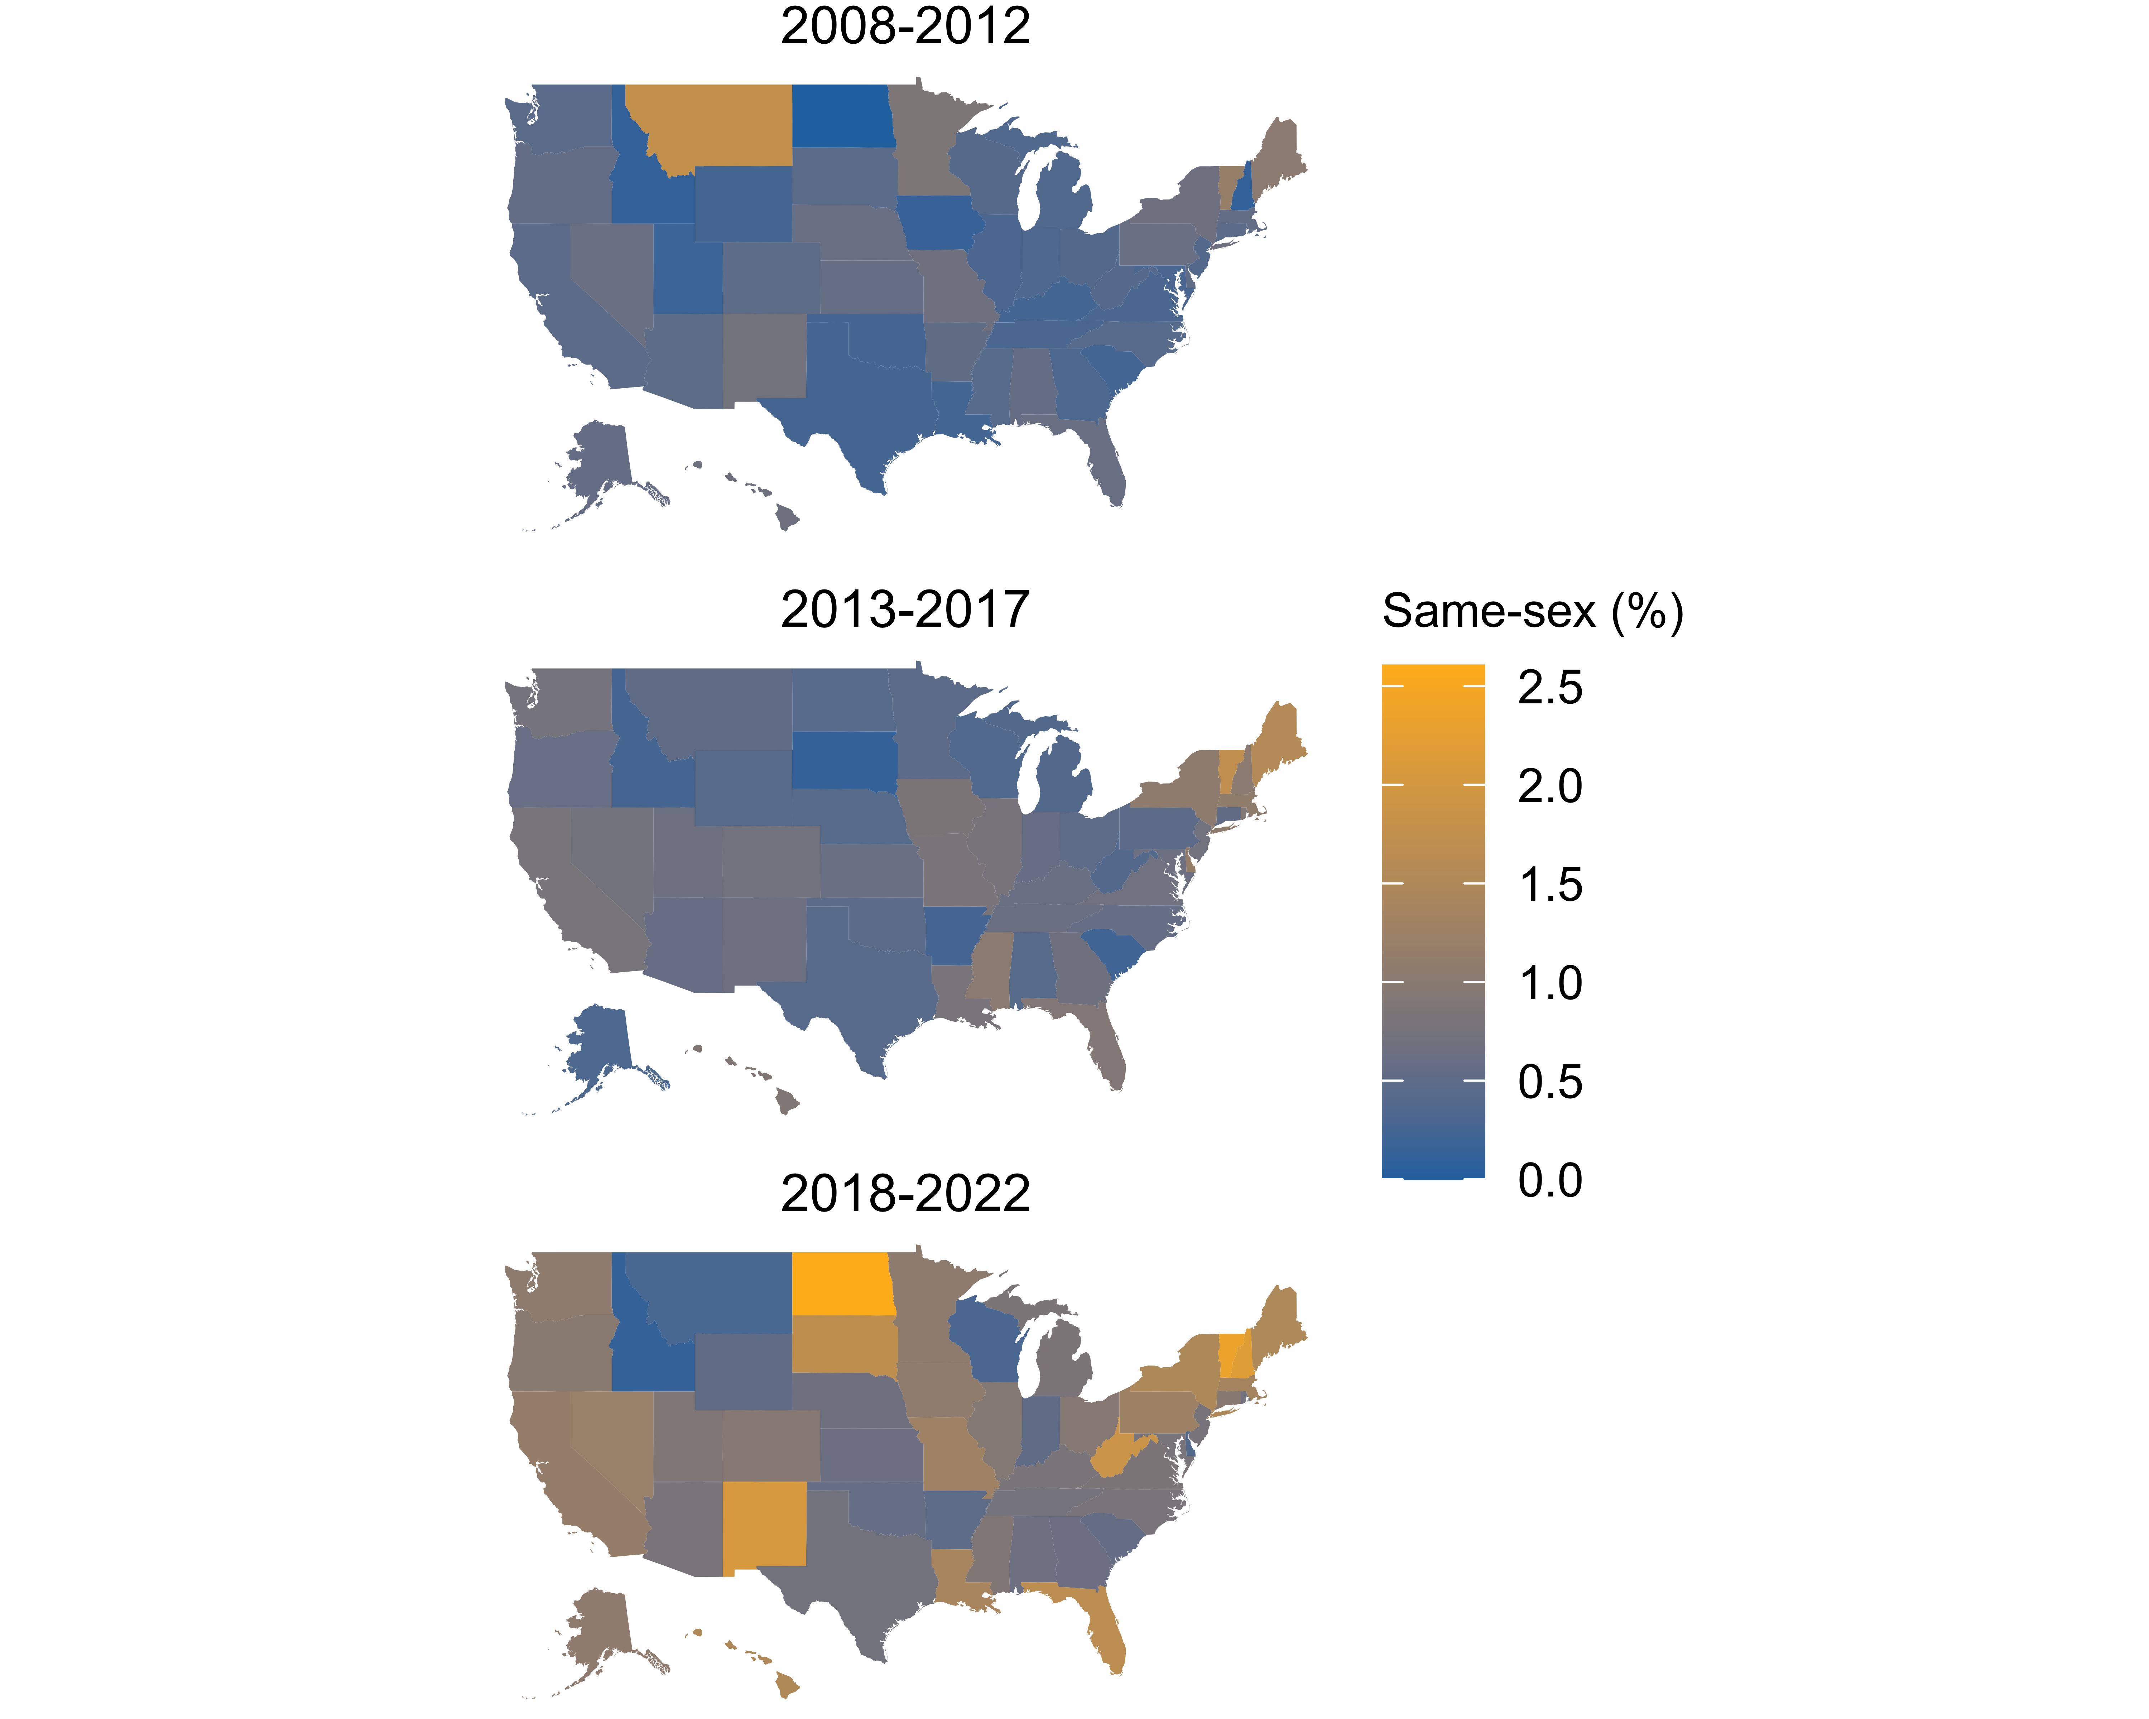

Figure 1: Percentage of cohabiting immigrants in same-sex couples in U.S. states, averaging over ACS survey years 2008 to 2022.

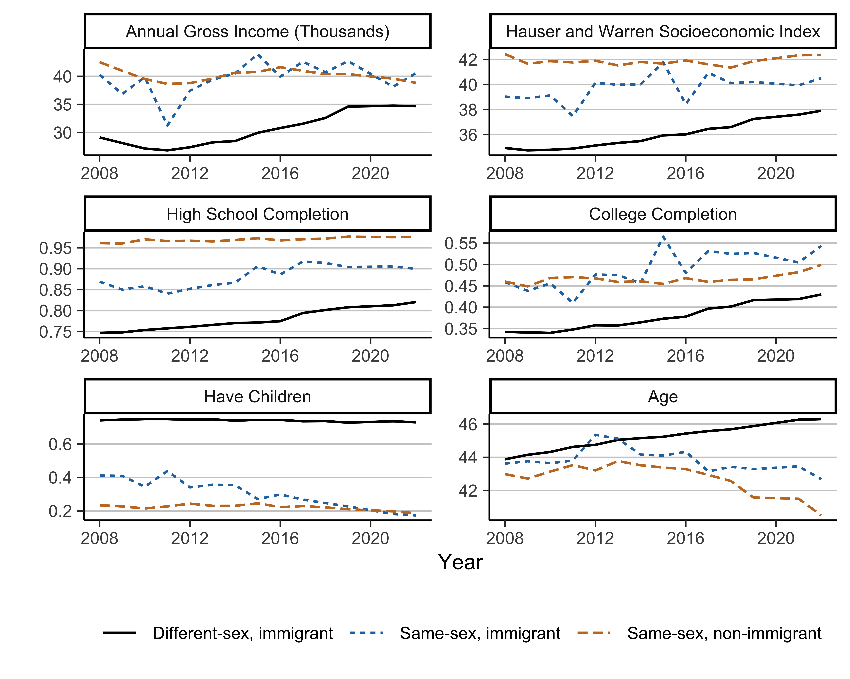

Figure 2: Individual characteristics over time for immigrants in different- and same-sex couples and non-immigrants in same-sex couples, based on American Community Survey data for 2008-2022. Estimates incorporate sampling weights.



Figure 3: Geographic characteristics over time for immigrants in different- and same-sex couples and non-immigrants in same-sex couples, based on American Community Survey data for 2008-2022. Estimates incorporate sampling weights.

# Appendix

# Appendix

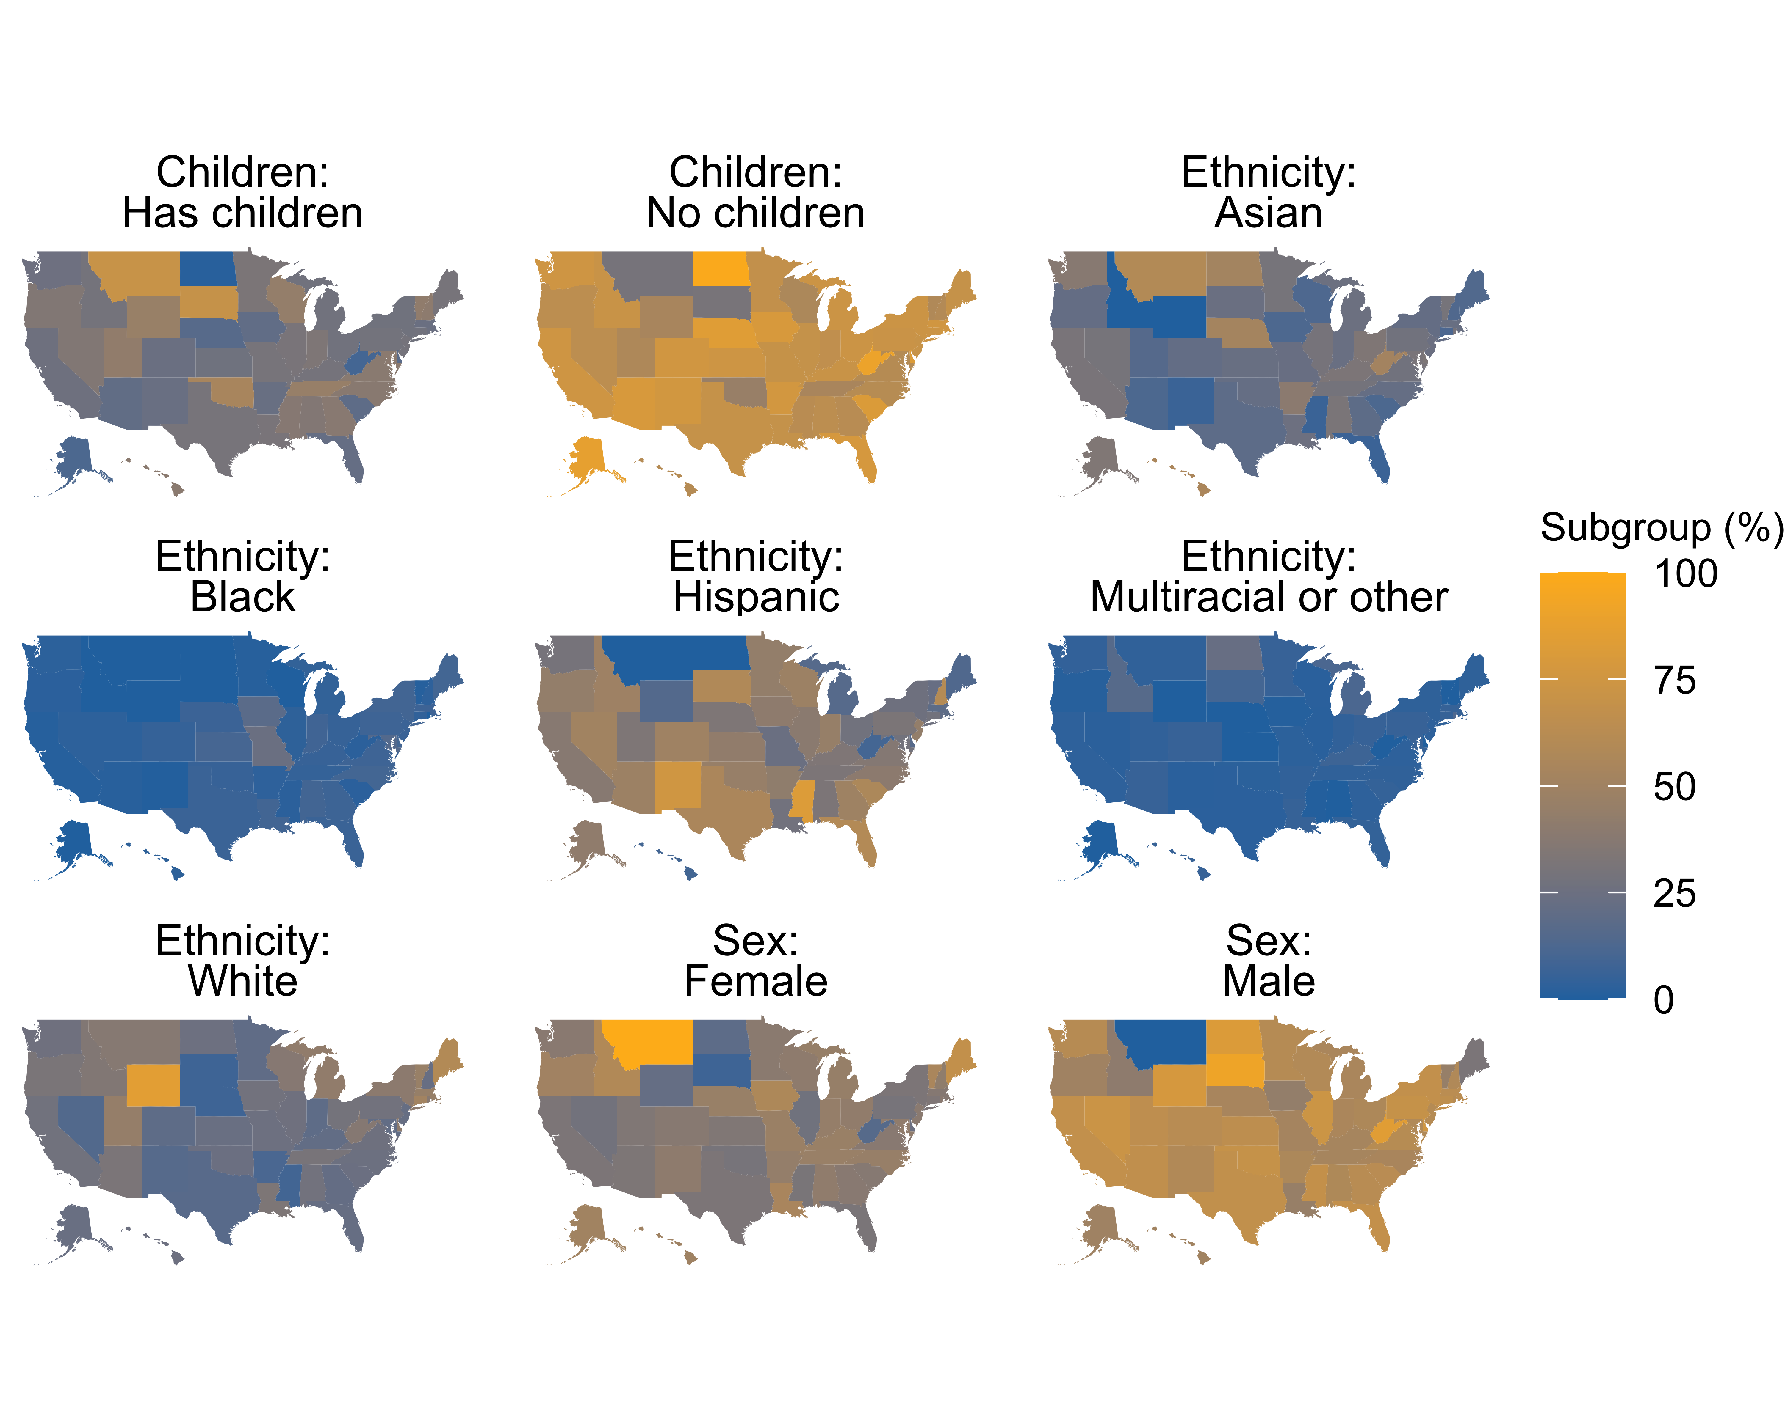

Figure 4: Percentage of migrants in same-sex couples in each state consisting of particular subgroups, from ACS estimates that incorporate sampling weights (2008-2019 and 2021-2022).

1. <https://www.lgbtmap.org/>
2. Note that we are constrained in reporting sex and gender by the questions asked in the ACS, which include only a binary option for sex and no question about gender.